Tutorial 11 - Graphs (solutions)
Week of 12 April 2010

- Connected components
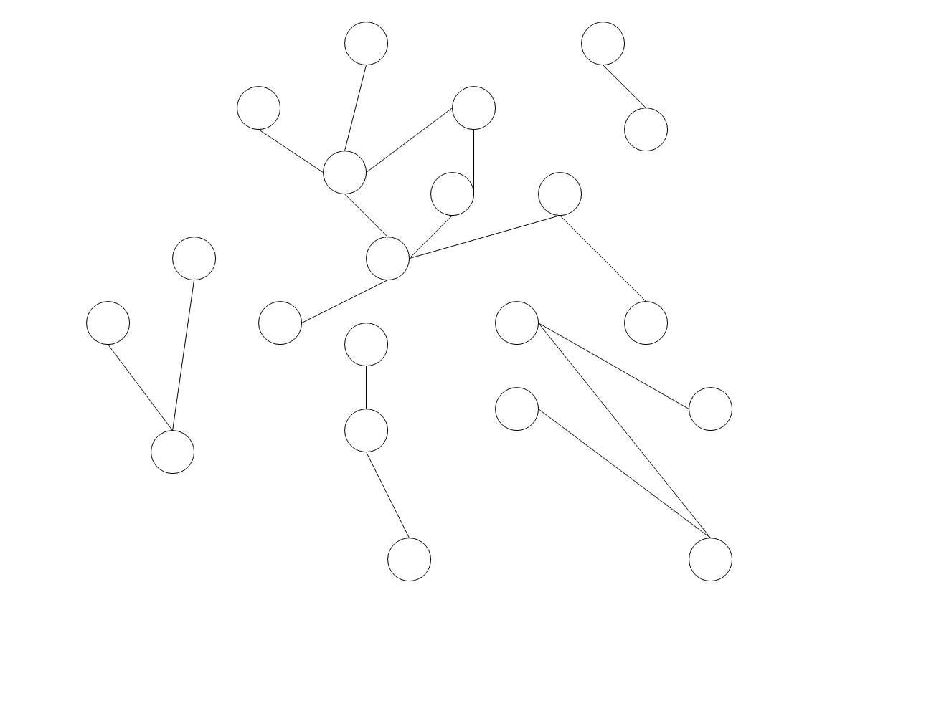
- A connected component is a set of vertices where there exists a path between all vertices in the component. How many connected components do you see in the undirected graph shown above? How many vertices belong to the largest component?
- The pseudocode

//main loop
for (each vertex v in the graph)
if (v has not yet been processed)
recursiveMethod(v);
…
recursiveMethod(v)
{
mark v as processed;
for (each v’ adjacent to v)
if (v’ has not yet been processed)
recursiveMethod(v’);
}

works on every vertex in a graph with n vertices and e edges. We assume the line “mark v as processed;” inside the recursiveMethod() where we process each v takes O(1) time to finish.
Suppose that the graph is represented as an array of adjacency lists. In "big-Oh" terms involving n and e, give the best estimate for the running time of the algorithm just given.

- Now suppose that the graph is represented as an adjacency matrix. Give the best estimate for the running time of the algorithm given in 1.b..

- How do you determine how many connected components are there in a graph? How do you determine how many vertices are in the largest connected component? You may want to modify the pseudocode in 1.b..

Answer:

a.
There are 5 of them.
The largest component contains 9 vertices.
b.
Using adjacency lists, the loop in the recursiveMethod is executed exactly 2*e times, reason:
Every time right after a vertex v_{i} is “processed”, it will call the recursiveMethod() on all its neighbors, i =1,2,..,n. The main loop guarantees that every vertex will be “processed” exactly once in the end; the number of times we test whether a neighbor has been “processed” inside the loop in recursiveMethod() equals to degree(v₁)+ degree(v₂)+… +degree(v_{n}), where degree(v_{i}) stands for the number of neighbors of v_{i}. Since it is an undirected graph, a pair of neighbors is counted both ways, thus the above expression equals to 2*e.
The main loop is executed n times, regardless of e. Thus the total execution time is O(n+e).

c.
With an adjacency matrix, determining what vertices are adjacent to a given vertex takes O(n) steps, and this is done for each vertex. Thus the total running time is O(n²).

d.
Big idea:
We can add a new integer type attribute to the vectex, called componentId for example, indicating which component this vertex belongs to. At first we initialize the componentId of every vertex to be 0, indicating the component of this vertex is not determined yet. We initialize another integer type variable, called componentCounter for example, indicating the number of different components in the graph. For each vertex v, if the componentId of v is 0, we increase the componentCounter by 1, and then we assign the componentId of v to be componentCounter by calling recursiveMethod(v, componentCounter), which will assign the componentId of the first parameter to be the value of the second parameter. Inside recursiveMethod(v, c), for each v’ adjacent to v, if v’ has not been “processed”, which means the componentId of v’ is 0, we pass the componentId of v to it by calling recursiveMethod(v’, c). In the end, we have assigned connected component(s) to all vertices, and all vertices inside a connected component share the same componentId value. The componentCounter is the number of connected components.
In order to find the size of the largest connected components, we can simply use a sizeOfLargestComponent to indicate the current maximum component size. We can set recursiveMethod() to return a integer type to indicate the number of vertices which get their componentId assigned during this method call. If we call this method from the main loop, the return type will tell us the size of this component. We simply update the sizeOfLargestComponent if needed.

We only demonstrate the pseudocode:

//initialization
for (each vertex v in the graph){
set the componentId of v to be 0;
}
componentCounter = 0;
sizeOfLargestComponent = 0;

//main loop
for (each vertex v in the graph){
if (the componentId of v is 0){
componentCounter++;
temp = recursiveMethod(v, componentCounter);
if (temp is larger than sizeOfLargestComponent)
sizeOfLargestComponent = temp;
}
}
…
int recursiveMethod(v, c)
{
set the componentId of v to be c;
sizeOfComponent = 1;
for (each vertex v’ adjacent to vertex v)
if (the componentId of v’ is 0)
sizeOfComponent += recursiveMethod(v’, c);
return sizeOfComponent;
}

- Is This Graph a Tree?

Definition: Tree T is a special graph G with either one the following properties hold:
- G is connected and |E| = |V| - 1
- G is acyclic and |E| = |V| - 1
- There exists a unique path between every pair of vertices in G

Create a simple pseudo code to determine whether a given graph G (a set of vertices and edges) is actually a tree using property A (the simplest), i.e. “bool isTree(Graph G)”. You can try property B or C on your own. Assume that the graph is stored as Adjacency List and the size of |V| and |E| are given.

Hint: What are the nodes reachable from a single call of DFS(starting vertex v)?

Answer:

bool IsTree(G) // Modification of Search(G) from lec note
foreach vertex v
mark v as unvisited

totalComponents = 0
foreach vertex v
if v is not visited {
totalComponents++
DFS(v)
}

// test whether G is connected (1 component only)
// and check the size of |E| and |V|
return (totalComponents == 1) && (|E| = |V| - 1);

- Topological Sort

The graph below contains information about (some) CS1102 materials and their dependencies, i.e. the materials must be taught “in certain order” so that students can understand the materials. For example, the concept of linked list must be taught before tree data structure, graph must be taught after tree, etc. Note that this sample graph does not model course materials perfectly! Answer the questions with respect to THIS graph!

Graph

Table Tree/BST → Heap

ADT → List → Linked List → Stack&Queue Recursion → Sorting & Complexity

Array/Vector Hashing

Suppose your lecturer/TA have taught this course for many years and wants to have a fresh challenge by reordering the syllabus. However, given the dependency constraints like the one shown in the graph above, he cannot do much…

- Use topological sort algorithm taught in class to come up with one valid topological order. Topological order is a linear ordering of these CS1102 materials that satisfy the dependency constraint. If when there are two possible choices (ties), we choose the one with lower lexicographic order, e.g. after processing Tree/BST, then “Graph” and “Heap” become available, enqueue “Graph” first as “G”raph is lexicographically smaller than “H”eap.

- The result of part a), if done correctly, will be quite different from the current CS1102 syllabus. Please suggest few edge constraint(s) in the dependency graph to force all “List” data structures discussed before “Table” data structures.
  - “List” data structures include “ADT List”, “Array/Vector”, “Linked List”, and “Stack & Queue” as we implement them using array/vector or linked list.
  - “Table” data structures include “ADT Table”, “Tree/BST”, and “Hashing”.

- Please list down two additional logical orderings of these CS1102 materials according to the given graph plus your modifications in part b) above. Note that you do NOT need to use the topological sort algorithm taught in lecture.

Answer:
a.
With normal queue with the lexicographic constraint above:
Queue = [ADT, Recursion]; enqueue all vertices with 0 incoming edges “A”DT first.
Output = ADT
Queue = [Recursion, List, Table], the two additional items are sorted based on “L”, “T”
Output = ADT, Recursion
Queue = [List, Table, Sorting & Complexity]
Output = ADT, Recursion, List
Queue = [Table, Sorting & Complexity, Array & Vector, Linked List]
Output = ADT, Recursion, List, Table
Queue = [Sorting & Complexity, Array & Vector, Linked List]
Output = ADT, Recursion, List, Table, Sorting & Complexity
Queue = [Array & Vector, Linked List]
Output = ADT, Recursion, List, Table, Sorting & Complexity, Array & Vector
Queue = [Linked List, Hashing]
Output = ADT, Recursion, List, Table, Sorting & Complexity, Array & Vector, Linked List
Queue = [Hashing, Stack & Queue, Tree/BST]
Output = ADT, Recursion, List, Table, Sorting & Complexity, Array & Vector, Linked List, Hashing
Queue = [Stack & Queue, Tree/BST]
Output = ADT, Recursion, List, Table, Sorting & Complexity, Array & Vector, Linked List, Hashing, Stack & Queue
Queue = [Tree/BST]
Output = ADT, Recursion, List, Table, Sorting & Complexity, Array & Vector, Linked List, Hashing, Stack & Queue, Tree/BST
Queue = [Graph, Heap]
Output = ADT, Recursion, List, Table, Sorting & Complexity, Array & Vector, Linked List, Hashing, Stack & Queue, Tree/BST, Graph
Queue = [Heap]

Finally, the output is not like current CS1102 syllabus, but still a valid topological order according to the given graph:
ADT, Recursion, List, Table, Sorting & Complexity, Array & Vector, Linked List, Hashing, Stack & Queue, Tree/BST, Graph, Heap.

b.
We may add “Stack & Queue → Table” to say that Stack & Queue (the last item classified as “List” data structure) must be taught before the lecturer can mention Table ADT. Then add edge “Table → Hashing” to force hashing to be discussed after both Array & Vector and Table have been discussed.

c.
(depending on the answer of part b):

Option 1 (reorder graph, hashing and heap lectures):
ADT, List, Array/Vector, Linked List, Stack & Queue, Recursion, Sorting & Complexity, Table, Tree/BST, Graph, Hashing, Heap.

Option 2 (do Recursion, then Sorting & Complexity in front so that we can discuss recursive methods and Big-O notations starting from Linked List lecture):
ADT, Recursion, Sorting & Complexity, List, Array/Vector, Linked List, Stack & Queue, Table, Tree/BST, Graph, Heap, Hashing

